A JOIN clause is used to combine rows from two or more tables, based on a related column between them.

SQL INNER JOIN Example
The INNER JOIN keyword selects all rows from both tables as long as there is a match between the columns.
SELECT column_name(s)
FROM table1
INNER JOIN table2 ON table1.column_name = table2.column_name;
SELECT Orders.OrderID, Customers.CustomerName
FROM Orders
INNER JOIN Customers ON Orders.CustomerID = Customers.CustomerID;

- (INNER) JOIN: Returns records that have matching values in both tables
- LEFT (OUTER) JOIN: Return all records from the left table, and the matched records from the right table
- RIGHT (OUTER) JOIN: Return all records from the right table, and the matched records from the left table
- FULL (OUTER) JOIN: Return all records when there is a match in either left or right table
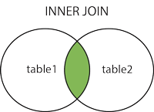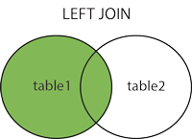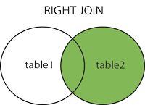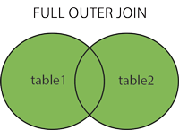

SQL FULL OUTER JOIN Keyword

SELECT column_name(s)
FROM table1
FULL OUTER JOIN table2 ON table1.column_name = table2.column_name;

